**ASSIGNMENT 10.3**

Use temp_data to solve below queries :

CREATE AND LOAD

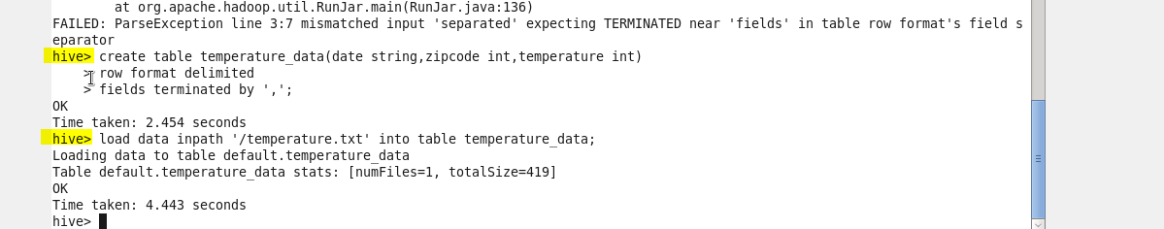

1 . Fetch date and temperature from temperature_data where zip code is greater than 300000 and less than 399999.

query :

SELECT date,temperature from temperature_data where zipcode>300000 AND zipcode<399999;

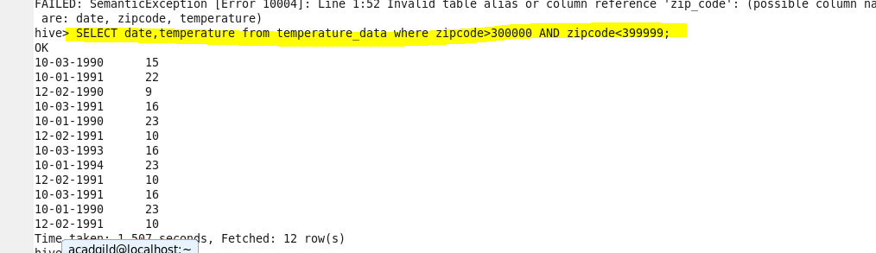

2. Calculate maximum temperature corresponding to every year from temperature_data table.

query :

SELECT YEAR(FROM_UNIXTIME(UNIX_TIMESTAMP(date,'dd-mm-yyyy'))) as date, MAX(temperature) as max_temp FROM temperature_data GROUP BY YEAR(FROM_UNIXTIME(UNIX_TIMESTAMP(date,'dd-mm-yyyy')));

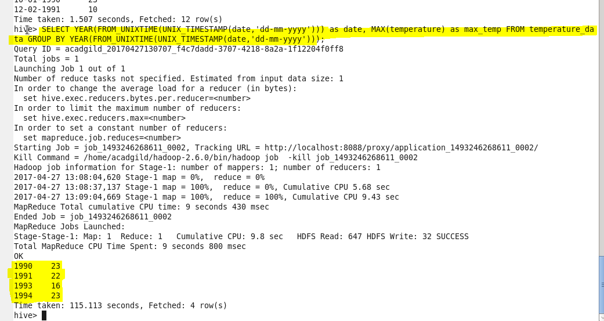

3. Calculate maximum temperature from temperature_data table corresponding to those years which have at least 2 entries in the table

query:

SELECT YEAR(FROM_UNIXTIME(UNIX_TIMESTAMP(date,'dd-mm-yyyy'))) as date, MAX(temperature) as max_temp FROM temperature_data GROUP BY YEAR(FROM_UNIXTIME(UNIX_TIMESTAMP(date,'dd-mm-yyyy'))) HAVING COUNT(date)>=2;

